**The SK Salon (website)**

**User’s Manual**

**for IT Support Services**

Prepared by: Haley Hardwick

**Revision Sheet**

|  |  |  |
| --- | --- | --- |
| **Release No.** | **Date** | **Revision Description** |
| Rev. 0 | 4/17/17 | User’s Manual Created |
|  |  |  |
|  |  |  |
|  |  |  |
|  |  |  |
|  |  |  |

**USER’S MANUAL**

**TABLE OF CONTENTS**

Page #

***1.0*** ***GENERAL INFORMATION***

**1.1** **Purpose 1**

***2.0*** ***WEBSITE NAVIGATION 2-1***

**2.1** **The SK Salon (Home page) 2-2**

**2.2 About, Services, Stylists, Products 2-3**

**2.3** **Photo Gallery 2-4**

**2.4** **Contact 2-5**

***3.0 ADMINISTRATIVE PORTAL* 3-1**

**3.1** **Log-In 3-2**

**3.2** **Admin 3-3**

**3.2.1 Logo 3-3**

**3.2.2 Admin Users 3-4**

**3.3** **Home 3-5**

**3.3.1 Home: New Content 3-5**

**3.3.2 Home: Edit/Delete Content 3-6**

**3.4** **About, Services, Stylists, Products 3-7**

**3.4.1 About, Services, Stylists, Products: New Content 3-7**

**3.4.2 About, Services, Stylists, Products: Edit/Delete Content 3-8**

**3.5** **Photos 3-9**

**3.6** **Inventory 3-10**

**1.0 GENERAL INFORMATION**

**GENERAL INFORMATION**

**1.1** **Purpose**

The purpose of this manual is to show the user(s) how to navigate and utilize both the front and backend of The SK Salon website.

**2.0 WEBSITE NAVIGATION**

**WEBSITE NAVIGATION**

The following displays the websites main navigation bar located at the top of this screen and all subsequent pages. The tabs on the navigation bar are as follows:

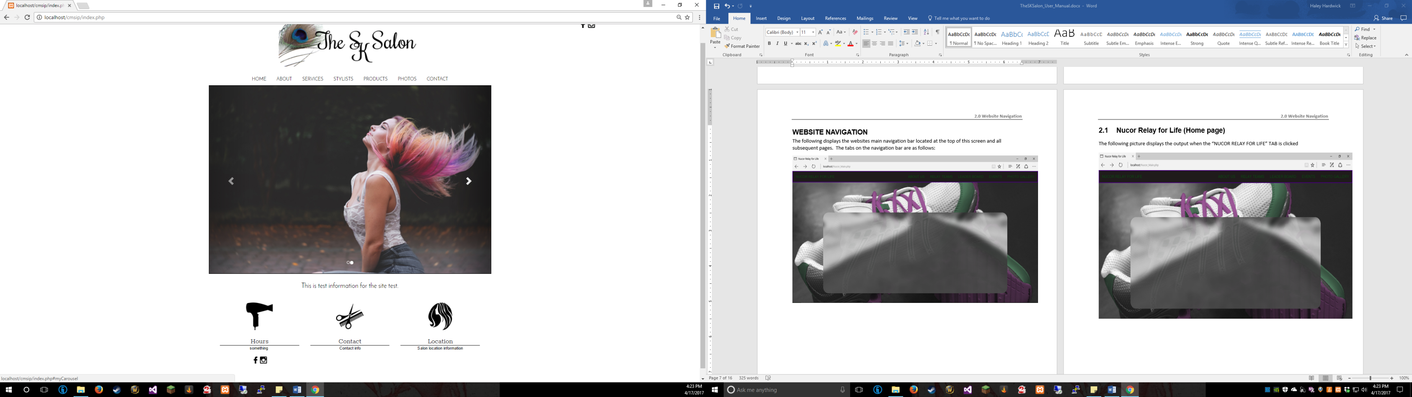

**2.1 The SK Salon (Home page)**

The following picture displays the site’s home page with test data inserted:

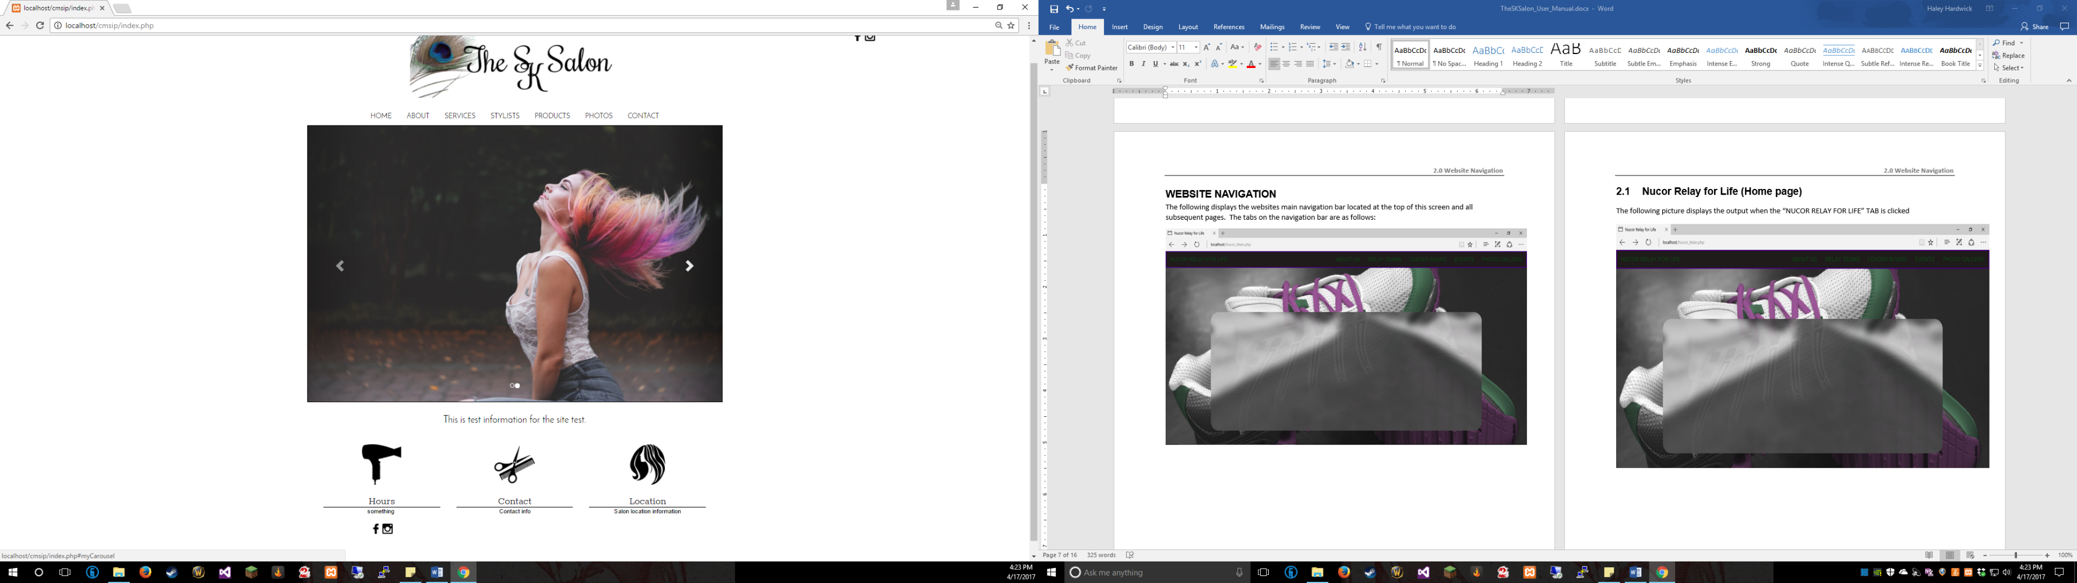

**2.2 About, Services, Stylists, and Products**

The following picture displays a sample of the styling for each of the listed pages. Each of these pages is laid out in a grid pattern consist throughout the About, Services, Stylists, and Products pages.

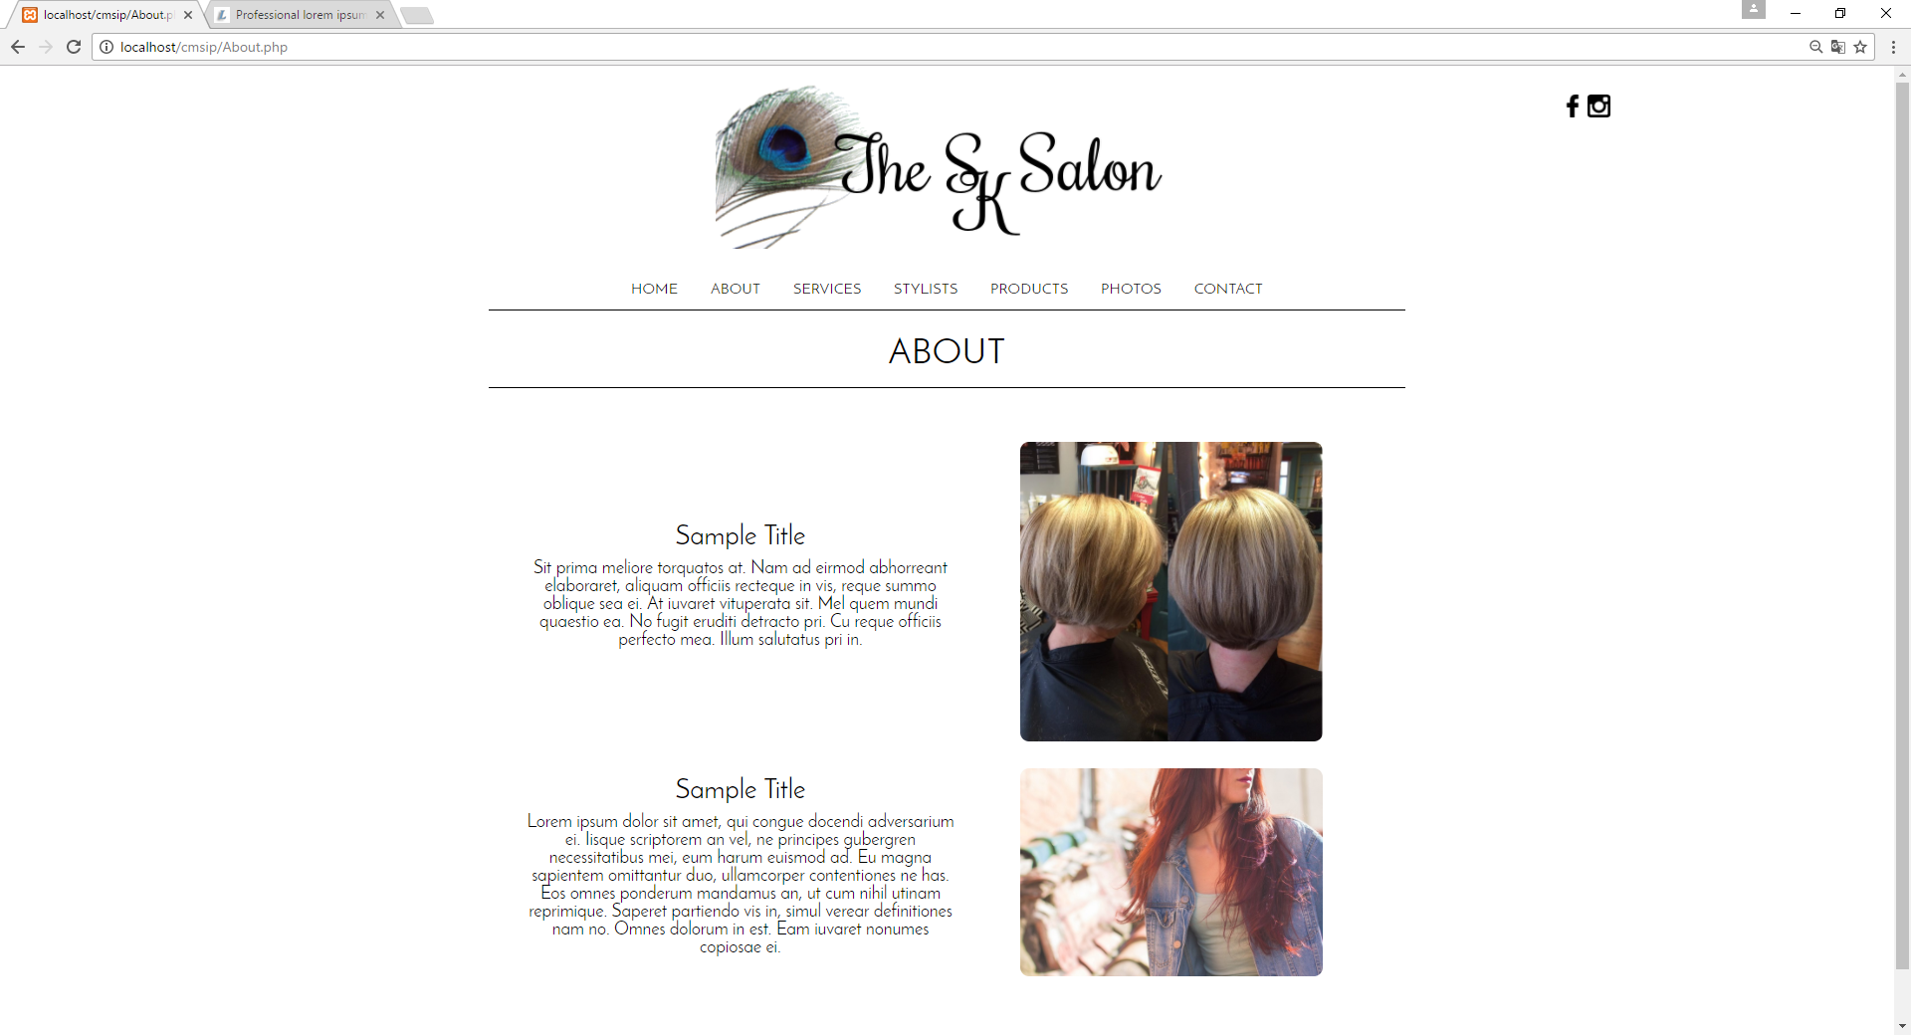

**2.3** **Photo Gallery**

The following picture displays the photo gallery, which was laid out in a three-column grid pattern. The photo gallery contains a light box, which allows the user to click a picture to display it full size and navigate through the pictures using the buttons.

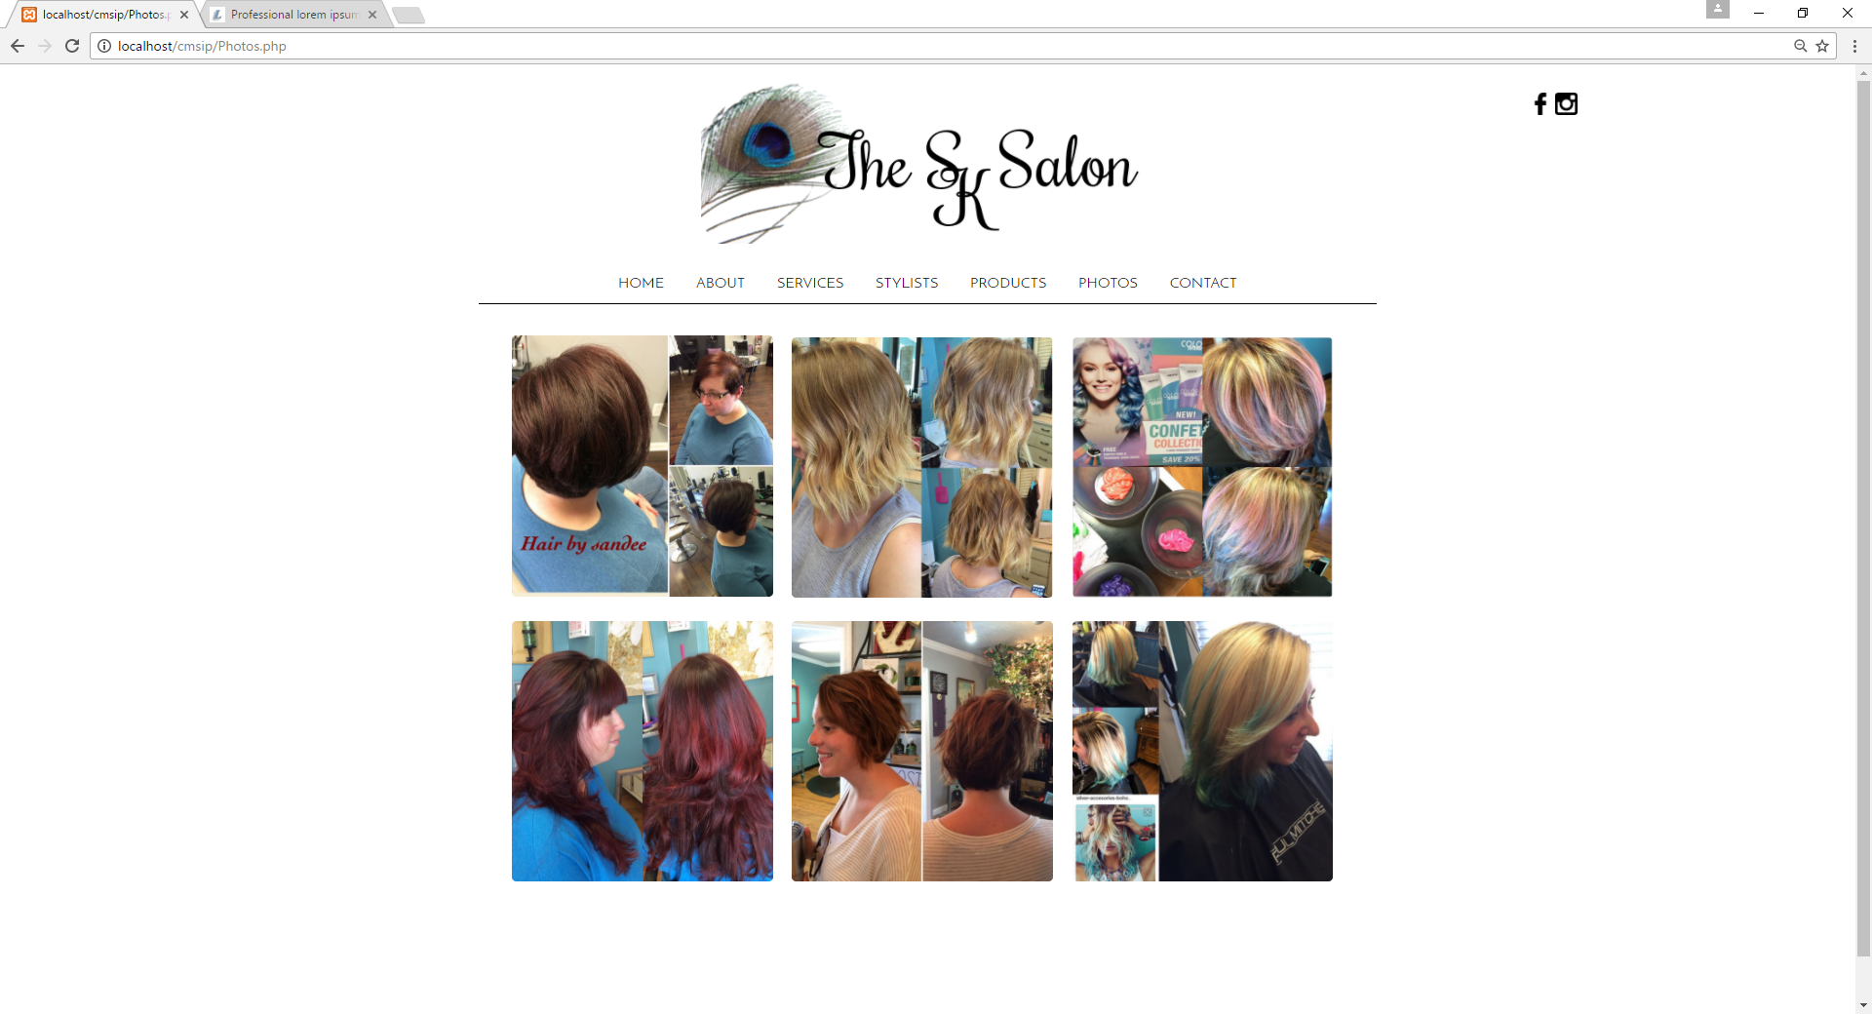

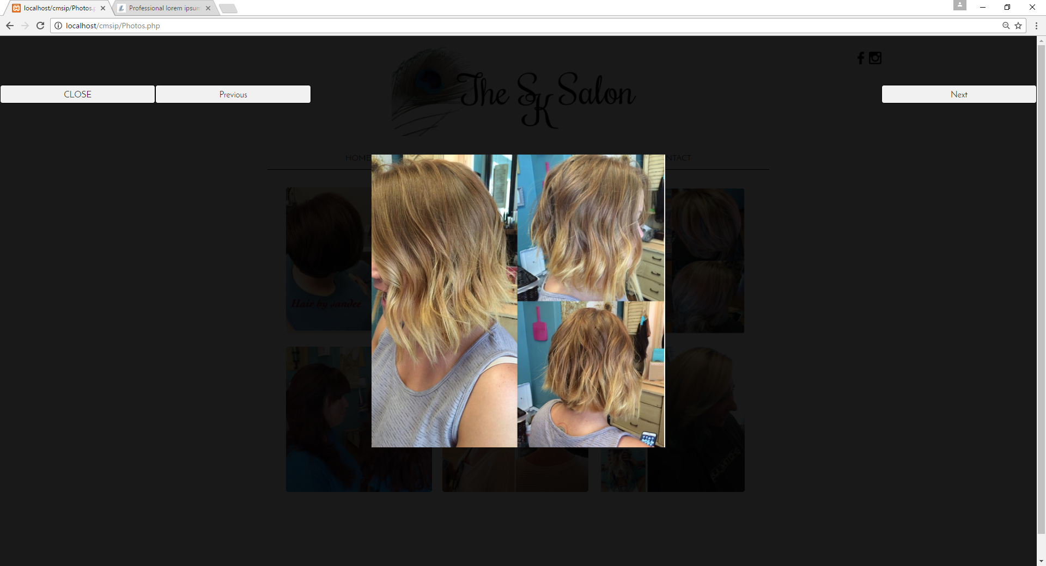

**2.4 Contact**

The following picture displays the contact page’s form allowing users to interact with The SK Salon as well as get a map of the salon’s location.

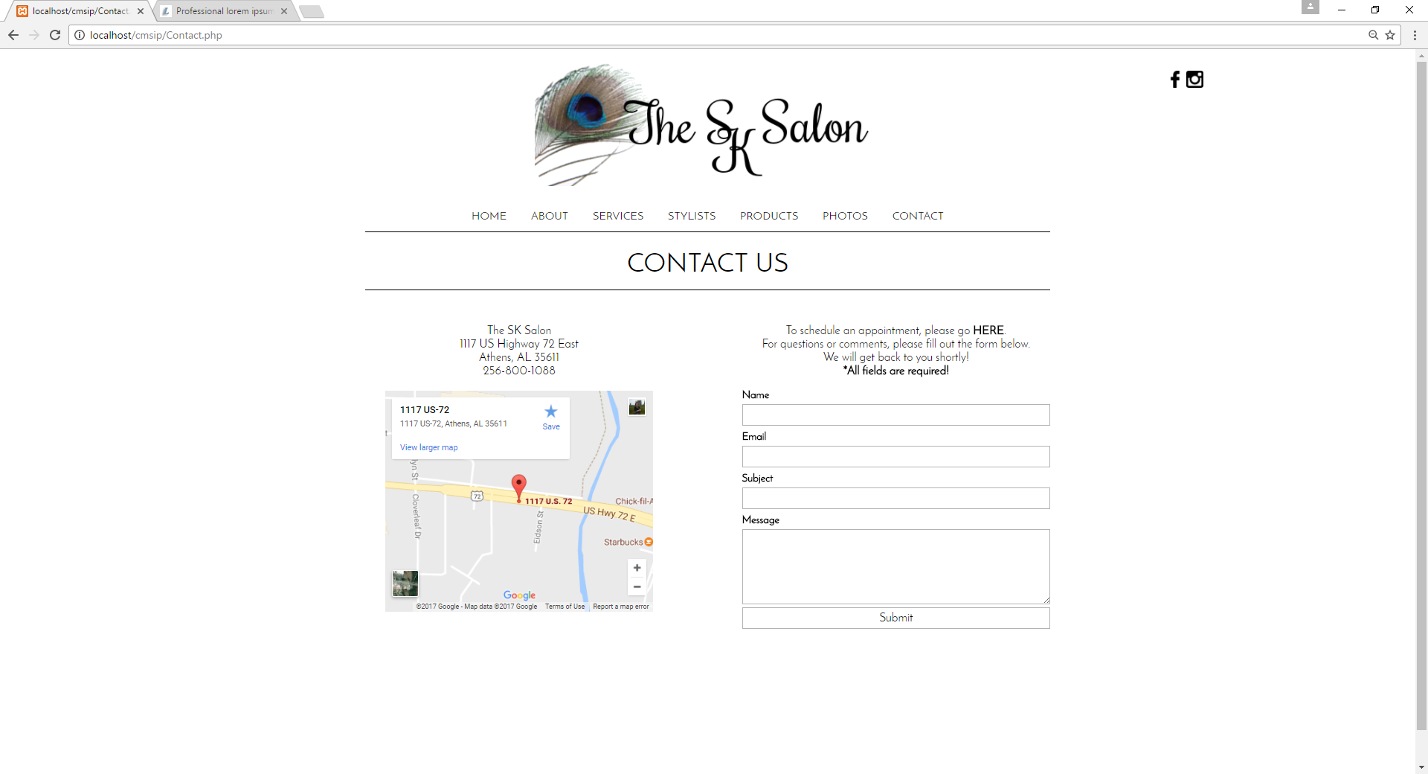

**3.0 ADMINISTRATIVE PORTAL**

**3.1 Administrative Portal: Logging In**

To log in to the administrative portal, click the small link located at the bottom of any page. Then log in with the administrator account information. This information has been set, but may be changed after logging in the first time. (**Username**: admin **Password**: 1234)

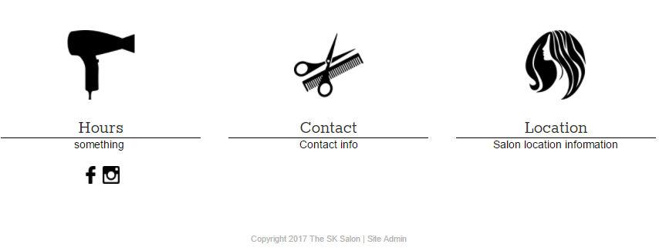

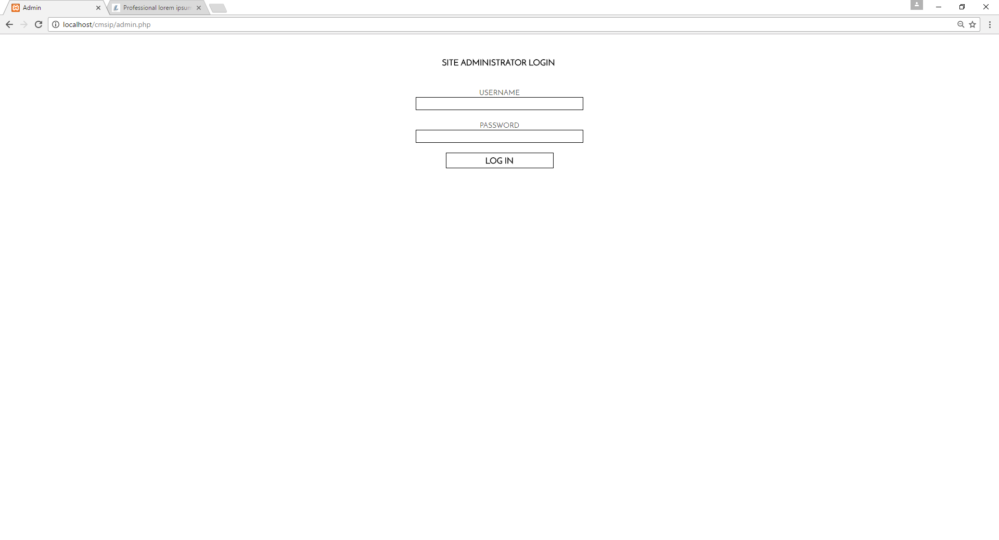

**3.2.1 Admin Page: Site Logo**

The Admin page is the first page of the administrative portal. It contains places to change the website’s logo as well as a place to add new users to the administrative portal. To choose a new logo, click Choose File under the All Pages tab and select your image file. Click Update.

To add a new user or view current users, select either View Users to view all administrative users, or Add New User to create a new user for the administrative portal.

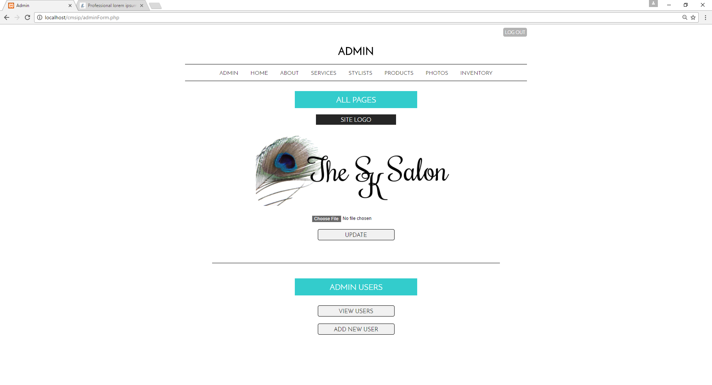

**3.2.2 Admin Page: Admin Users**

To add a new user or view current users, select either View Users to view all administrative users (or Edit or Delete user information), or Add New User to create a new user for the administrative portal.

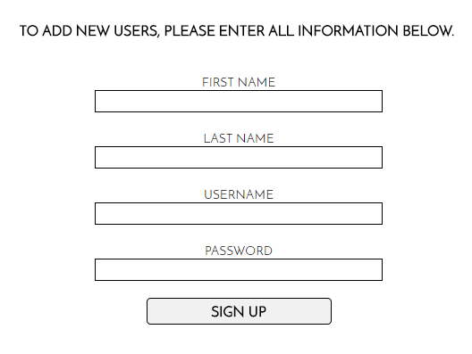 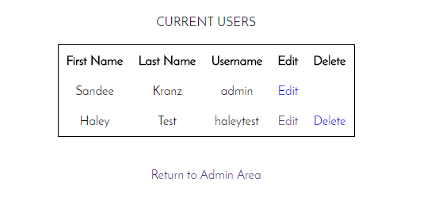

**3.3.1 Home: New Content**

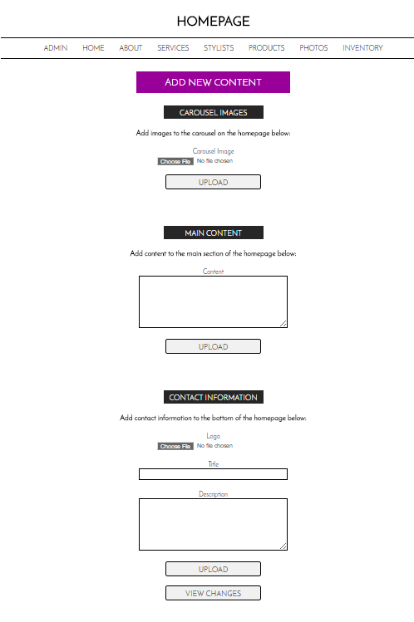The Home tab will allow you to create new content for your first page or edit any information currently displayed on your home page. To Add new content, look under the Add New Content heading and update as appropriate. You can include new carousel images, main text, or blocks for the bottom of the website by looking for the appropriate subheadings. Don’t forget to click the upload buttons to save changes. To view your work, select View Changes.

Subheadings are labeled in **black**.

Insert new content with the text boxes or choose image files by clicking **Choose File.**

Click **View Changes** to see how your new content looks on the page!

Don’t forget to click **Upload** when you’ve finished your new content!!

**3.3.2 Home: Edit/Delete Content**

The Edit Current Content heading will allow you to edit or delete content for the home page. To edit, simply edit the text or select choose file to change images. When you’ve made your selections, click Update. To delete an item, find the delete button underneath the content your wish to delete.

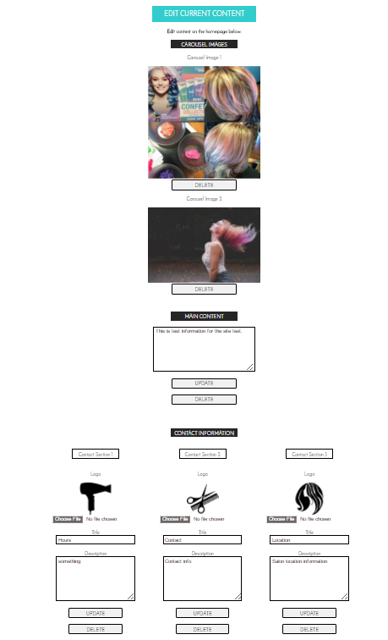

Click **Update** to save your changes or **Delete** to get rid of the block entirely.

Click **Choose File** to update an image. Simply alter the text in the text box as needed.

Click **Delete** underneath any item you wish to delete.

**3.4.1 About, Services, Stylists, Products: New Content**

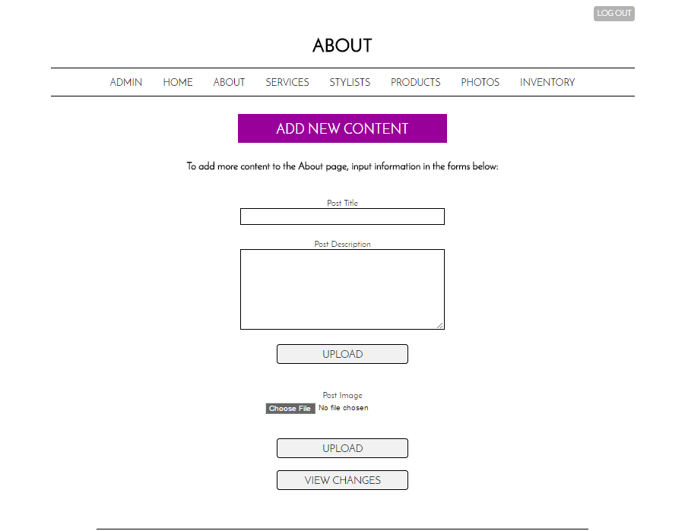The following directions are pertinent to the About, Services, Stylists, and Products pages. To add new content, look under the **Add New Content** heading and update as appropriate. You can include new images or text by looking for the appropriate subheadings. Don’t forget to click the upload buttons to save changes. To view your work, select View Changes.

Don’t forget to click **Upload** when you’ve finished your new content!!

Click **View Changes** to see how your new content looks on the page!

Insert new content with the text boxes or choose image files by clicking **Choose File.**

**3.4.2 About, Services, Stylists, Products: Edit/Delete Content**

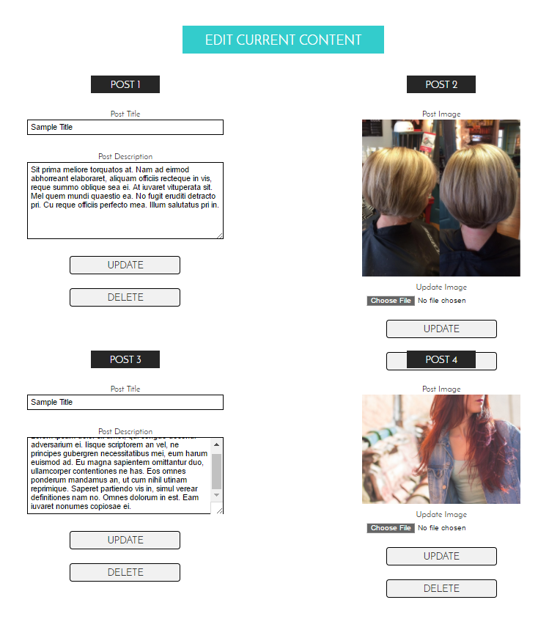The following directions are pertinent to the About, Services, Stylists, and Products pages. To edit or delete content, scroll down until you see **Edit Current Content**.

Click **Delete** underneath any item you wish to delete.

Click **Update** to save your changes or **Delete** to get rid of the block entirely.

**3.5.1 Photos**

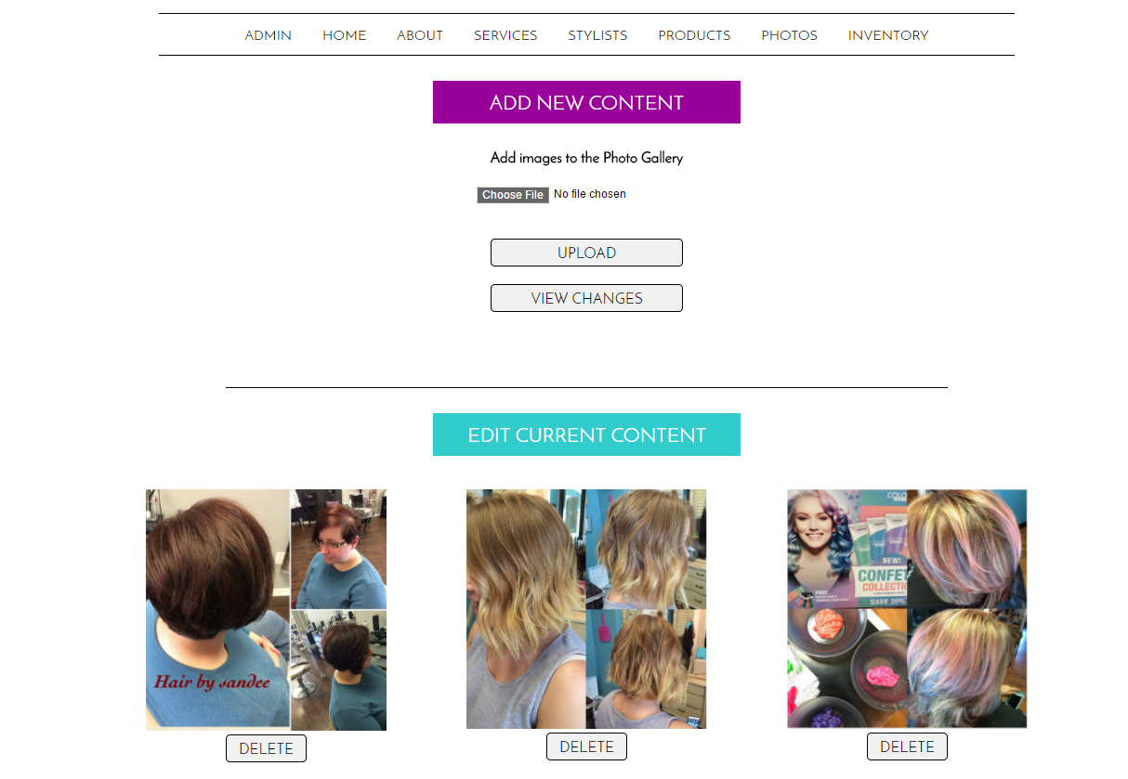The photo gallery can be amended at any time by either adding new content or delete old content. These photos will appear in the grid structure on the Photos page.

Click **View Changes** to see how your new content looks on the page!

Don’t forget to click **Upload** when you’ve finished your new content!!

Insert new content with the text boxes or choose image files by clicking **Choose File.**